3/10/2024
Data Analysis CA
Semin Islamovic 22434792
NATIONAL COLLEGE OF IRELAND

PART 1
Dataset search and selection process:
As part of my online search for an appropriate dataset related to a multiple regression problem, I engaged in the exploration of numerous different repositories. These various repositories included examples such as Sports Statistics, UCI Machine Learning Repository, Data.world and Kaggle which were all based upon my personal interests of topics. This was my main priority by finding a suitable dataset to meet the assignment requirements and to be associated with something I am interested in and keen to research about.
Given my prior experience with the Kaggle repository, I went ahead and browsed it the most as I was familiar with it already. I have a very strong interest in the video game industry and therefore decided to search for video game sales datasets specifically to the requirement needs of this assignment.
After carefully reviewing and comparing datasets among various repositories, I came across the “Video Game Sales” [1] dataset on the website Kaggle. This selected dataset caught my attention as it consisted of diverse information about video games sales among various regions globally. This dataset contains attributes such as platform, global sales numbers, genre, publisher, and year making it an appropriate dataset for regression analysis.

How and why the selected Dataset meets the requirements:
The main reason I chose this dataset on Video Game Sales is because of its appropriateness for this assignment. This dataset consists of both categorical and numerical attributes as its mentioned in the assignment criteria. Examples of numerical attributes include specific region sales figures, global sales figures which open the opportunity for quantitative data so we can use for our regression analysis, while the categorical attributes include examples such as platform, year, publisher which can offer us knowledgeable insights.
The dataset itself is quite large as it contains 11 attributes and 16,598 instances. This size makes sure that we have the minimum dataset size requirements and that we have enough data to work with for our regression analysis. By using all these attributes in the dataset, we can build sufficient regression models to predict the global sales numbers. Another point I want to briefly mention is that this dataset is completely different and new to me, which also meets the requirements for this assignment.

PART 2
Question 1:
By analysing our summary descriptive statistics table on our video games sales dataset, we can pinpoint out a few interesting findings. First off, the mean of the global sales number is 0.537, which tells us straight away the average sales per video game in millions. We have relatively low mean averages for North America with 0.265 and the EU with 0.146. Moving onto the standard deviation of Global sales which is 1.555 which tells us about some variability in sales numbers.
We can also catch out some outliers as for example, North American sales have a maximum of 41.49 with a minimum of exactly 0 which is quite unusual indicating there could be come errors or missing values. I would say the distribution of the global sales seems skewed to the right, by having outliers with very high sales and other games having quite low sales. To finish this off this first part of my dataset exploration, we can compare the mean of the global sales with various platforms, etc. to see which contain high or low average sales in the later stages of this analysis. Below is the summary of the descriptive statistics table.

 | Rank | Year | NA_Sales | EU_Sales | JP_Sales | Other_Sales | Global_Sales
count | 16598.000000 | 16327.000000 | 16598.000000 | 16598.000000 | 16598.000000 | 16598.000000 | 16598.000000
mean | 8300.605254 | 2006.406443 | 0.264667 | 0.146652 | 0.077782 | 0.048063 | 0.537441
std | 4791.853933 | 5.828981 | 0.816683 | 0.505351 | 0.309291 | 0.188588 | 1.555028
min | 1.000000 | 1980.000000 | 0.000000 | 0.000000 | 0.000000 | 0.000000 | 0.010000
25% | 4151.250000 | 2003.000000 | 0.000000 | 0.000000 | 0.000000 | 0.000000 | 0.060000
50% | 8300.500000 | 2007.000000 | 0.080000 | 0.020000 | 0.000000 | 0.010000 | 0.170000
75% | 12449.750000 | 2010.000000 | 0.240000 | 0.110000 | 0.040000 | 0.040000 | 0.470000
max | 16600.000000 | 2020.000000 | 41.490000 | 29.020000 | 10.220000 | 10.570000 | 82.740000

Question 2:
In this section, we will discuss about the missing values in our dataset and how we will handle them. Missing values or errors are almost a guarantee every time you deal with new datasets presented to you, so it is essential to do some preprocessing and data cleaning for your analysis to come out with a better outcome. Upon exploring my dataset on Microsoft Excel by plain sight, I could identify some missing inputs in the “Year” attribute which were denoted as “NaN”, while some values in the “Publisher” attribute were shown as “Unknown”.
The first step we took to deal with these missing values is removing the rows in the attribute “Year” that were empty as I found it the most straight forward method. We then went ahead and did things differently for the “Publisher” attribute where we replaced each missing value with the mode of values already in the column. By doing this, we were now able to clearly see that there were no more missing values in these columns, which greatly boosts our chances of the data being reliable for regression analysis. We also did an extra step by getting rid of any duplicate values we may have in our dataset.

Rank | Name | Platform | Year | Genre | Publisher | NA_Sales | EU_Sales | JP_Sales | Other_Sales | Global_Sales
0 | 1 | Wii Sports | Wii | 2006.0 | Sports | Nintendo | 41.49 | 29.02 | 3.77 | 8.46 | 82.74
1 | 2 | Super Mario Bros. | NES | 1985.0 | Platform | Nintendo | 29.08 | 3.58 | 6.81 | 0.77 | 40.24
2 | 3 | Mario Kart Wii | Wii | 2008.0 | Racing | Nintendo | 15.85 | 12.88 | 3.79 | 3.31 | 35.82
3 | 4 | Wii Sports Resort | Wii | 2009.0 | Sports | Nintendo | 15.75 | 11.01 | 3.28 | 2.96 | 33.00
4 | 5 | Pokemon Red/Pokemon Blue | GB | 1996.0 | Role-Playing | Nintendo | 11.27 | 8.89 | 10.22 | 1.00 | 31.37
... | ... | ... | ... | ... | ... | ... | ... | ... | ... | ... | ...
16593 | 16596 | Woody Woodpecker in Crazy Castle 5 | GBA | 2002.0 | Platform | Kemco | 0.01 | 0.00 | 0.00 | 0.00 | 0.01
16594 | 16597 | Men in Black II: Alien Escape | GC | 2003.0 | Shooter | Infogrames | 0.01 | 0.00 | 0.00 | 0.00 | 0.01
16595 | 16598 | SCORE International Baja 1000: The Official Game | PS2 | 2008.0 | Racing | Activision | 0.00 | 0.00 | 0.00 | 0.00 | 0.01
16596 | 16599 | Know How 2 | DS | 2010.0 | Puzzle | 7G//AMES | 0.00 | 0.01 | 0.00 | 0.00 | 0.01
16597 | 16600 | Spirits & Spells | GBA | 2003.0 | Platform | Wanadoo | 0.01 | 0.00

Question 3:
In this section we dive into the exploration of the distribution of our data using plots. We first went ahead and used the Boxplot to look at the distribution of all our numerical attribute values. The output of the all the boxplots appeared to be very uniform and flat which means something isn’t correct. Few reasons this may occur is maybe our data has little variability or we need to identify outliers and remove them from our analysis.
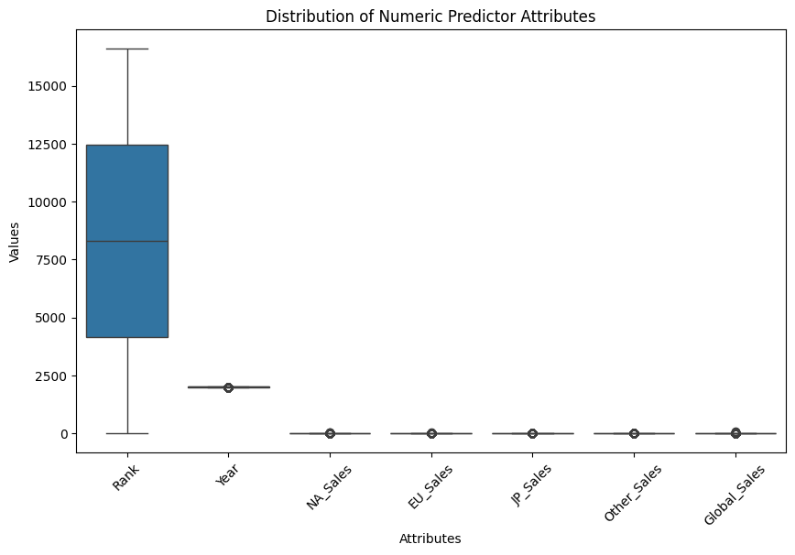
Question 4:
The next step, we must do is visualising a single numeric attribute against a categorical attribute and to interpret its results. We need to introduce a new module which is denoted as “%matplotlib inline” which deals with attributes that contains categorical values. In our case we chose the numerical attribute “Global sales” and the categorical attribute as “Platform”. From our chart below, we can straight away tell that Nintendo Entertainment System, and the Game Boy console platforms had the highest number of global sales with NES having 2.5 million and GB having approximately 2.7 million. So, we can conclude that these were the most popular platforms globally. We also have a uneven distribution across the whole chart. We can also see that the PCFX console had the lowest number sales of around 0.2 million.
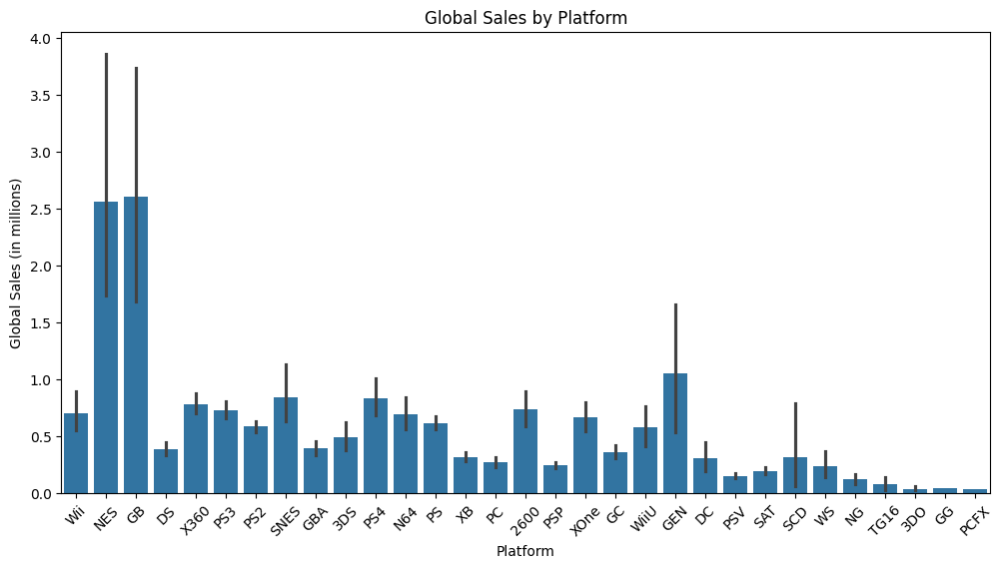
Question 5:
For this next section of this assignment, we need to compute and graphically present the correlations between the numeric attributes by utilizing a correlation matrix. We have decided to present this matrix in a heatmap so that is it easier to visualize. By looking at the correlation matrix we can see that European Union sales and North American sales are strongly correlated. This means that as they both increase, the global sales increase as well.
We can also say that the “Year” and “Global Sales” attributes have a strong negative correlation as it indicates that as the year increases, the global sales decrease. Below is shown a visual representation of the correlation matrix.

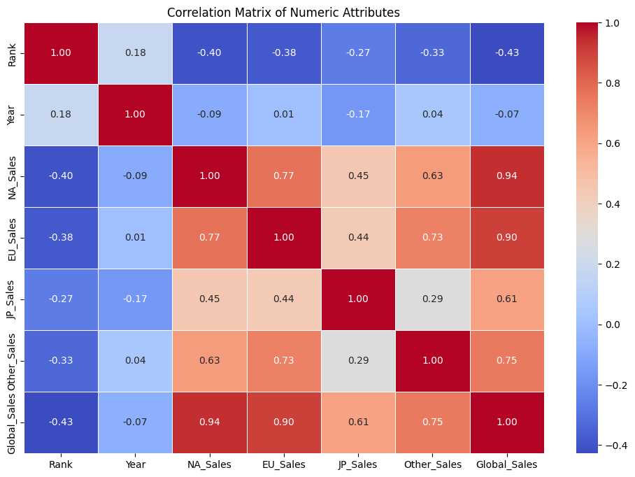
Question 6:
Now we want to visualise graphically the relationship of one categorical and one numeric attribute. In our case, we will be using the “Genre” and “Global sales” attributes as our selected categorical and numerical values. I also chose to create a bar plot as I find it the easiest to understand and interpret from looking at it directly.
As we can see in the chart below, we can clearly see and investigate the average global sales by each video game genre. We can straight away see that platform and shooter games contain the highest number of global sales. While adventure and strategy seem to be our outliers with very little numbers of global sales compared to the rest. By looking at the rest of our genres, they seem to all evenly distributed.
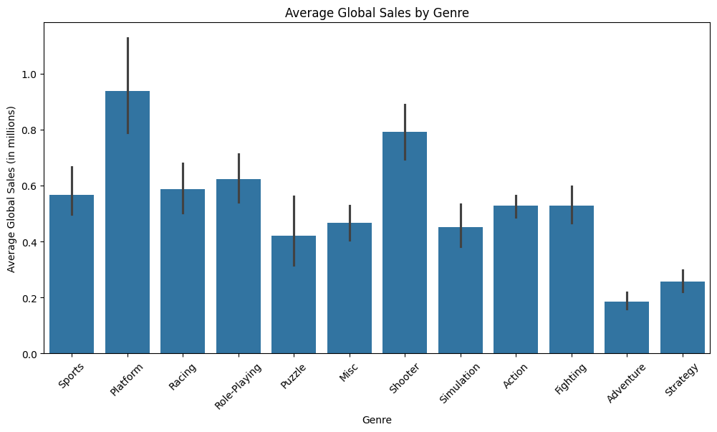

Question 7:
We now must create a new categorical target attribute that is based upon the numeric target attribute which in this case is “Global Sales”. We first must create three bins and add appropriate labels to them. The labels I chose were low sales (less than 1 million), medium sales (between 1 and 10 million) and finally high sales (more than 10 million).
The boxplot below clearly shows us distribution of the Years for games in each sector of global sales. By looking at the boxplot below, we can see that the medium number of sales is more evenly distributed than the others.

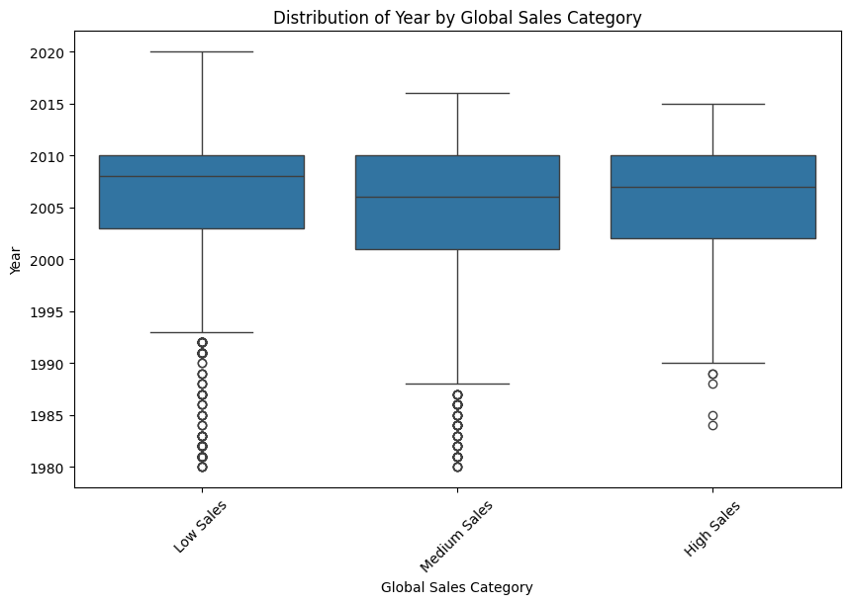

Question 8:
The next part is to transform all our categorical attributes into numerical values. We can do this by label encoding the categorical columns and turning them into binary digits. In our case, the attributes “Name”, “Genre”, “Platform”, and “Publisher” needs to be encoded. We first add in the label encoder. We also use fit transform method to fit the encoder to the attributes and change categorical values into numerical values. This is the most straightforward way as it simply converts the categorical values into numerical values. The label encoder works for only a single column so we must add it to every single categorical column we want to transform.
Rank Name Platform Year Genre Publisher NA_Sales EU_Sales \
0 1 11007 26 2006.0 10 359 41.49 29.02
1 2 9327 11 1985.0 4 359 29.08 3.58
2 3 5573 26 2008.0 6 359 15.85 12.88
3 4 11009 26 2009.0 10 359 15.75 11.01
4 5 7346 5 1996.0 7 359 11.27 8.89

JP_Sales Other_Sales Global_Sales
0 3.77 8.46 82.74
1 6.81 0.77 40.24
2 3.79 3.31 35.82
3 3.28 2.96 33.00
4 10.22 1.00 31.37

Question 9:
Our next task is to split the dataset in a Training and testing split. It is based on the last non-zero digit of your student ID. In my case, the student ID is 22434792. Due to my last non-zero number being 2, the split ratio was induced as 50% each both for training and the testing. By applying this, it makes sure we have an evenly balanced distribution of our data among the training and testing sets. This then opens the opportunity for strong mode training and outcome evaluation. In our code, we utilized a customised split strategy. This makes it much easier and more reliable for us when working on our analysis. Below is shown the code output:
Train ratio: 0.5
Test ratio: 0.5

Question 10:
Our following task now involves feature scaling in our modified dataset. Feature scaling is important as it makes sure that the numeric columns with unique units are being recognised by the model. By scaling the training and testing sets, we can prevent the possibility of data exploitation. In our case, we have chosen to use the Min-Max scaling method. This makes sure to scale our unique features in a specific range.
Our first step Is to separate the numeric columns from the training and testing sets. After that is completed, we can then scale the training set using this chosen Min-Max method. In the end, we just must do the same steps to the testing set also to come up results as shown in the chart below. This is a very simple and understandable approach and avoids bias which makes sure we receive a fair evaluation of the final model.
Scaled Train Set:
Rank Year NA_Sales EU_Sales JP_Sales Other_Sales Global_Sales
0 0.265152 0.756757 0.006190 0.019982 0.000000 0.006640 0.010937
1 0.876551 0.810811 0.000000 0.000000 0.002935 0.000000 0.000497
2 0.139475 0.918919 0.011004 0.043597 0.000000 0.011952 0.022123
3 0.188818 0.783784 0.004470 0.006358 0.000000 0.058433 0.015660
4 0.983612 0.594595 0.000000 0.000000 0.000978 0.000000 0.000000

Scaled Test Set:
Rank Year NA_Sales EU_Sales JP_Sales Other_Sales Global_Sales
0 0.434149 0.513514 0.004127 0.007266 0.000000 0.001328 0.005220
1 0.815038 0.621622 0.000688 0.001817 0.000000 0.001328 0.000746
2 0.638752 0.837838 0.000000 0.000000 0.009785 0.000000 0.002237
3 0.439149 0.756757 0.006534 0.000908 0.000000 0.002656 0.005220
4 0.597903 0.918919 0.000688 0.001817 0.005871 0.001328 0.002734

Question 12:
Our last step now involves applying Ridge Regression and Random Forest algorithms and comparing them using our dataset. Our goal is as before to predict “Global Sales” based on categorical attributes mentioned before. We went ahead and trained 100 estimators for the random forest model while the ridge regression, we dealt with its parameters.
Both Ridge regression and random forest often show very powerful predictive performance. The choices between the two, heavily depend on variables such as complexity of the model.
The ridge regression shows coefficient estimates for every predictor involved, which makes it much simpler to interpret while random forest lacks this simplicity of interpretation. The R-squared of the two indicate whether performance is good or not.
References:
[1] ‘🎮 EDA - VIDEO GAME SALES’. Accessed: Mar. 07, 2024. [Online]. Available: https://kaggle.com/code/upadorprofzs/eda-video-game-sales

